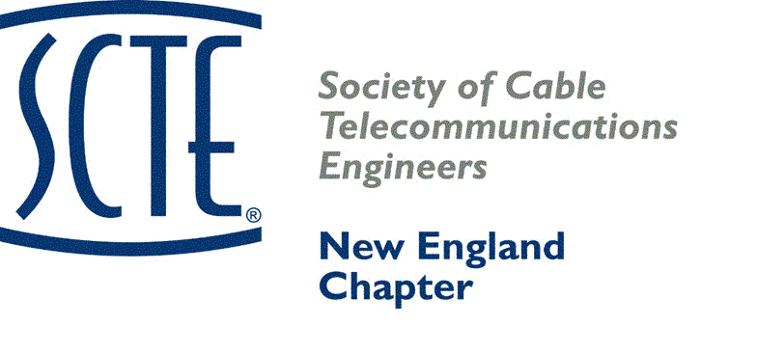

2025 SCTE NEW ENGLAND CHAPTER VENDOR DAY

# *BOOTH* SPACE APPLICATION

***THIS FORM MUST ACCOMPANY PAYMENT***

COMPANY:

## 

### CONTACT:

### ADDRESS: _____________________________________________________________

### CITY: _______________________________ STATE: _______ ZIP: ____________

PHONE: _____________________________ EMAIL:

NAMES OF PEOPLE ATTENDING FROM YOUR COMPANY:

_____ BOOTH FEE $550 before May 16th $750 after May 16th Qty _________ $________

_____ OUTSIDE DISPLAY SPACE $450 (with inside booth also add $150.) $ __________

____ YES FOR Platinum $800, Gold SPONSOR $600, OR Silver SPONSOR $400 $ ______

_____ YES FOR RAFFLE CONTRIBUTION: __________________________________________________

List Raffle Prize

_____ AC POWER **($75.00 ADDITIONAL CHARGE) $ ____________**

_____ RF FEED – (**$80.00 ADDITIONAL CHARGE) $ ____________**

_____ LUNCH TICKETS: Number of tickets: _____ $ ____________

(One lunch ticket is included with table purchase; $75 each for additional lunches.)

**CHECK ENCLOSED** (payable to SCTE New England) **TOTAL AMOUNT CHECK**: $______________

**Mail check to:**

**Peter Lovasco**

**Comcast**

**9 Forbes Road, Ste. 9B**

**Woburn, MA 01801**

If you haven't registered yet, please do so using the following link:

<https://cablelabs.my.site.com/scte/s/lt-event?id=a4NQj000000iH8P#/Registration>

# We have arranged a special SCTE hotel rate of $114 (single and double), plus tax per room with the Boxboro Regency Hotel. This rate will be available until June 10th and is subject to room availability. Please call 978-263-8701 and ask for the SCTE group rate.

**\*\* For credit card payments, please register on-line. \*\***

**New England Chapter**

**2025 Vendor Day Sponsorship**

This year we will again offer a tiered sponsorship program. This is a great opportunity for you and your company to support our Chapter Vendor Day event!

**Platinum Sponsorship $800**

Sponsorship Includes:

Company name displayed on the main page of our Website until next year’s event Reserved table and company name displayed at our annual Awards Luncheon Company name displayed in our exhibit halls Company recognition during our awards presentation

**Gold Sponsorship $600**

Sponsorship Includes:

Company name displayed on the main page of our Website until next year’s event

Reserved table and company name displayed at our annual Awards Luncheon

Company name displayed in our exhibit halls.

Company recognition during our awards presentation

**Silver Sponsorship $400**

Sponsorship Includes:

Company name displayed on the Vendor Day section of our Website

Company name displayed at our annual Awards Luncheon

Company name displayed in our exhibit halls.

Company recognition during our awards presentation

If you would like to participate as a sponsor, please check off the appropriate item on the registration form and include your check with your registration.

**The New England Chapter thanks you for your continued support!**

“Contributions or gifts to the Society of Cable Telecommunications Engineers are not tax deductible as charitable contributions. However, they may be tax deductible as ordinary and necessary business expenses.”

**Please provide a logo for your company that will be displayed**